🏠 AIRBNB MARKET ANALYTICS
Prepared By: Mahale Pradnesh
Date: January 2026
Analysis Scope: 280K Listings | 10 Cities | 5M Reviews

1. Project Overview
This analysis examines the global Airbnb market across 10 major cities (Paris, New York, Sydney, Rome, Rio, Istanbul, Mexico City, Bangkok, Cape Town, Hong Kong), providing actionable insights for hosts and investors based on 280K listings and 5 million guest reviews.

2. Dataset Summary
- Rows: 279712
- Columns: 33
- Missing Data: Missing values in name ,host_since ,host_location , host_response_time, host_response_rate, host_is superhost, host_total_listings_count, host_has_profile_pic, host_identity_verified, district,bedrooms, review_score_nights, review_score_accuracy, review_scores_cleanliness, review_scores_checkin, review_scores_communication, review_scores_location, review_scores_value columns

3. Exploratory Data Analysis using Python
We began with data preparation and cleaning in Python:
- Data Loading: Imported the dataset using pandas.

- Initial Exploration: Used listings.info(), listings.tail(), listings.head(), listings.isnull().sum() to check structure and listings.describe() for summary statistics.
- <class 'pandas.core.frame.DataFrame'>
- RangeIndex: 279712 entries, 0 to 279711
- Data columns (total 33 columns):
- # Column Non-Null Count Dtype
- --- ------ -------------- -----
- 0 listing_id 279712 non-null int64
- 1 name 279537 non-null object
- 2 host_id 279712 non-null int64
- 3 host_since 279547 non-null object
- 4 host_location 278872 non-null object
- 5 host_response_time 150930 non-null object
- 6 host_response_rate 150930 non-null float64
- 7 host_acceptance_rate 166625 non-null float64
- 8 host_is_superhost 279547 non-null object
- 9 host_total_listings_count 279547 non-null float64
- 10 host_has_profile_pic 279547 non-null object
- 11 host_identity_verified 279547 non-null object
- 12 neighbourhood 279712 non-null object
- 13 district 37012 non-null object
- 14 city 279712 non-null object
- 15 latitude 279712 non-null float64
- 16 longitude 279712 non-null float64
- 17 property_type 279712 non-null object
- 18 room_type 279712 non-null object
- 19 accommodates 279712 non-null int64
- 20 bedrooms 250277 non-null float64
- 21 amenities 279712 non-null object
- 22 price 279712 non-null int64
- 23 minimum_nights 279712 non-null int64
- 24 maximum_nights 279712 non-null int64
- 25 review_scores_rating 188307 non-null float64
- 26 review_scores_accuracy 187999 non-null float64
- 27 review_scores_cleanliness 188047 non-null float64
- 28 review_scores_checkin 187941 non-null float64
- 29 review_scores_communication 188025 non-null float64
- 30 review_scores_location 187937 non-null float64
- 31 review_scores_value 187927 non-null float64
- 32 instant_bookable 279712 non-null object
- dtypes: float64(13), int64(6), object(14)

- Missing Data Handling: Checked for null values and imputed missing values in the columns using the mean, median, mode and remove not useful /too missing columns.
Columns to DROP (not useful / too missing): host_location (not precise, messy),host_response_time (missing 50%+),host_response_rate (missing 50%+),host_acceptance_rate (missing 50%+),district (almost completely missing 242,700),review_scores_* subcategories (because overall rating exists),review_scores_cleanliness,review_scores_checkin,review_scores_communication,review_scores_location,review_scores_value
- Database Integration: Connected Python script to MySQL and loaded the cleaned DataFrame into the database for SQL analysis.

4.Data Analysis using SQL (Business Transactions)
We performed structured analysis in MySQL to answer key business questions:
  - Total listings by city – Which cities have more supply
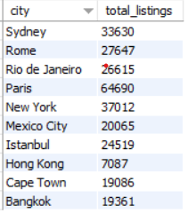
  - Average price by city – Which cities are premium/expensive
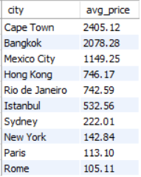
  - Property type distribution - Which property types dominate
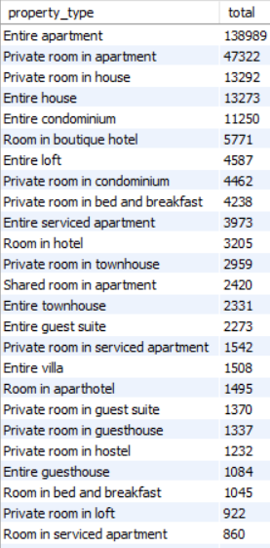
  - Pricing strategy insights –
  - Price vs room type –
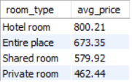
  - High-revenue potential properties - Assume revenue proxy = price × minimum_nights 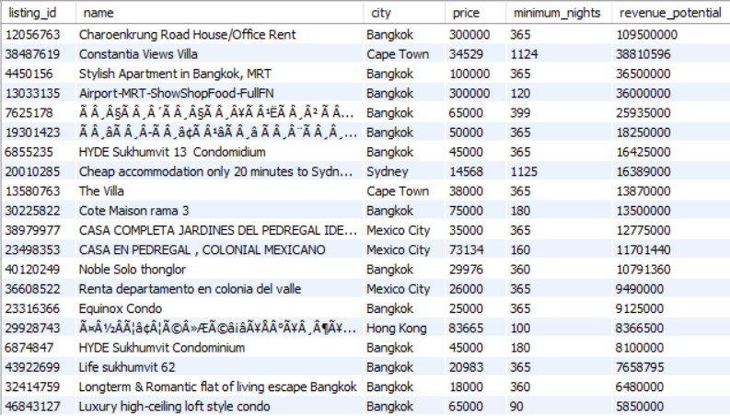
  - Review & rating insights
  - Average rating by city –
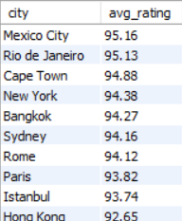
  - Price vs rating relationship –
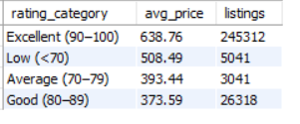
  - Popular capacity listings-
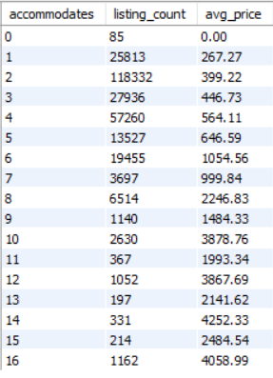
  - Superhost vs normal host pricing - 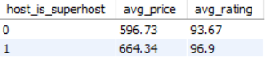
  - Location premium pricing - Which neighborhoods are premium investment zones
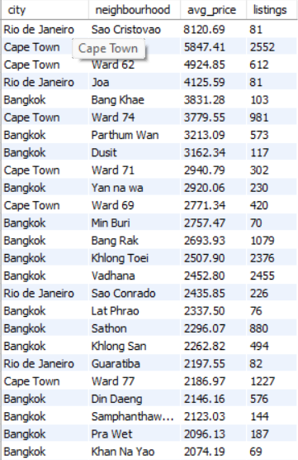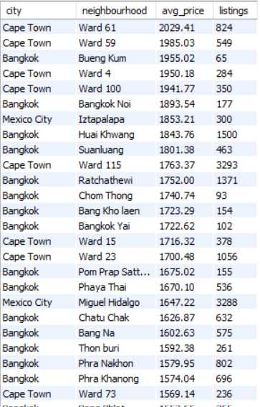

Dashboard in Power BI
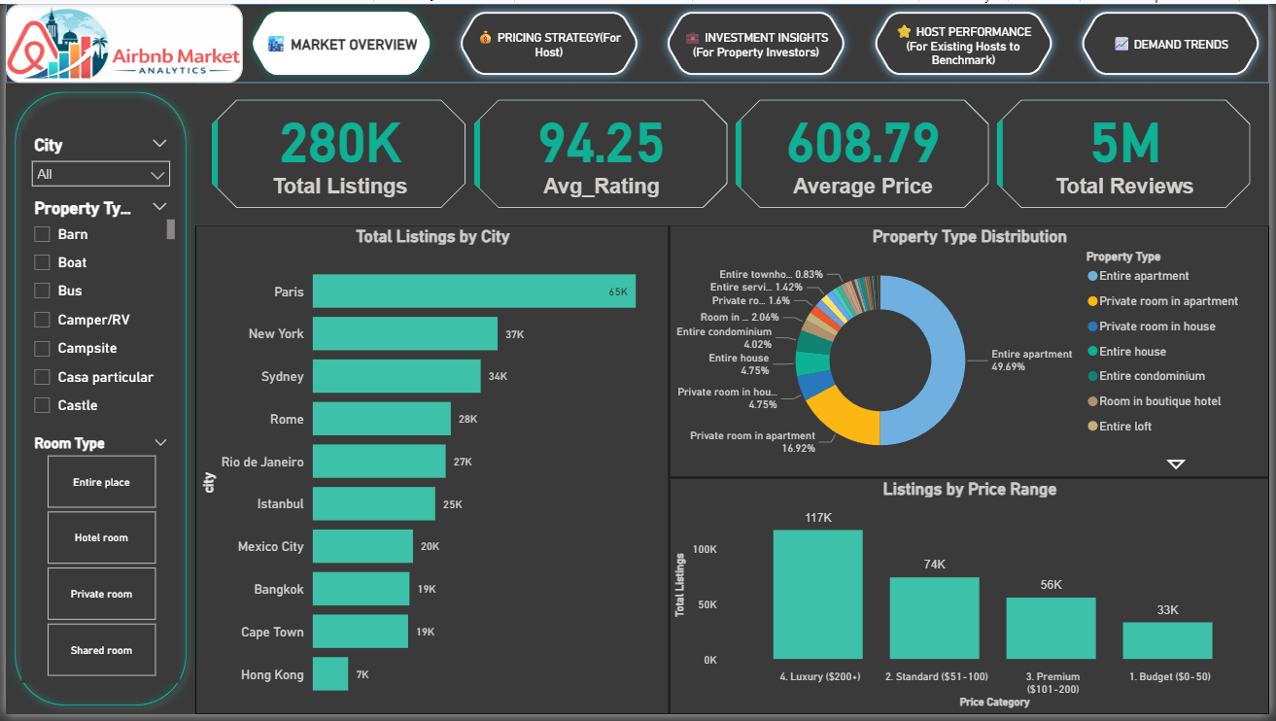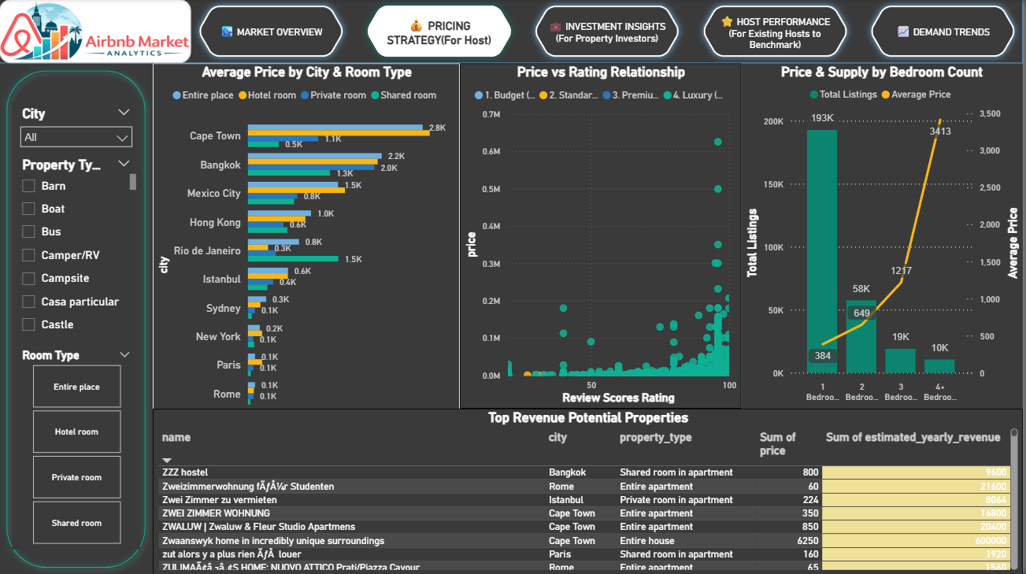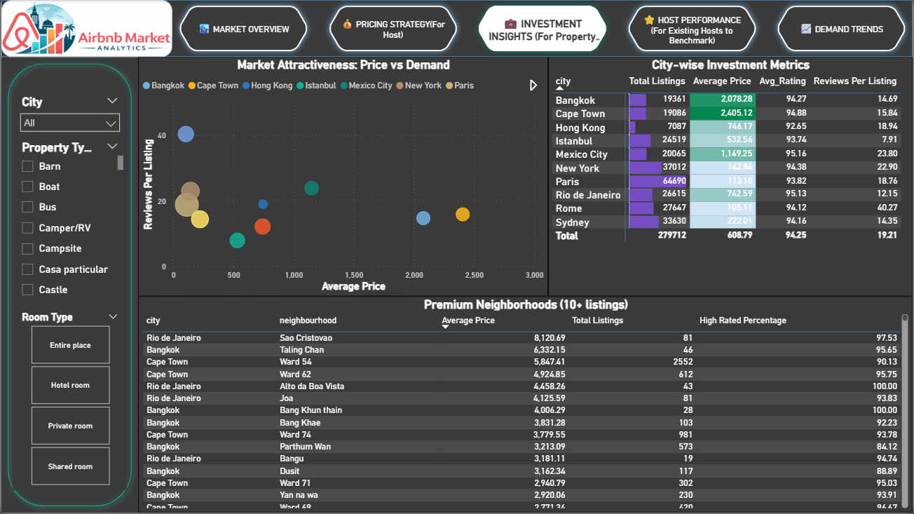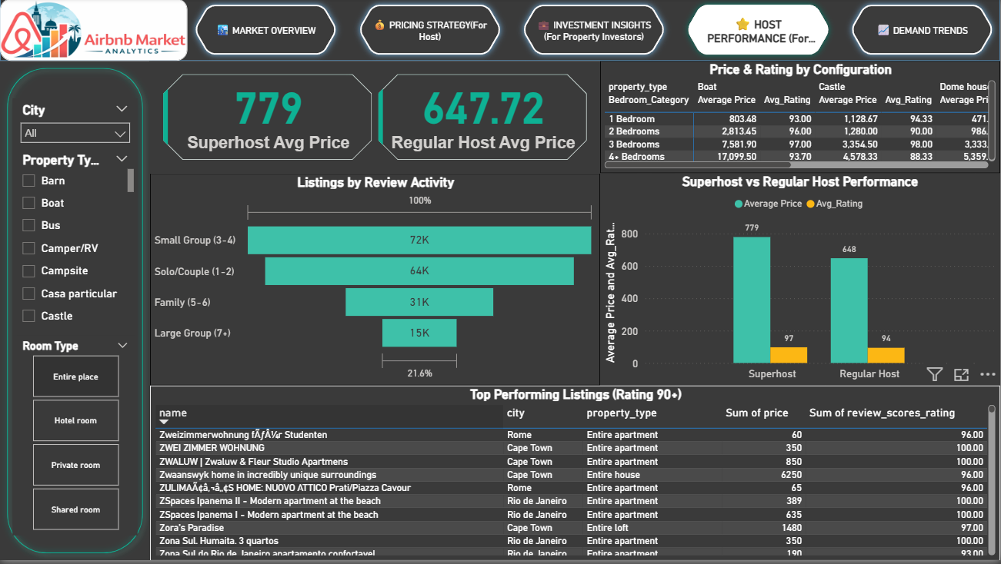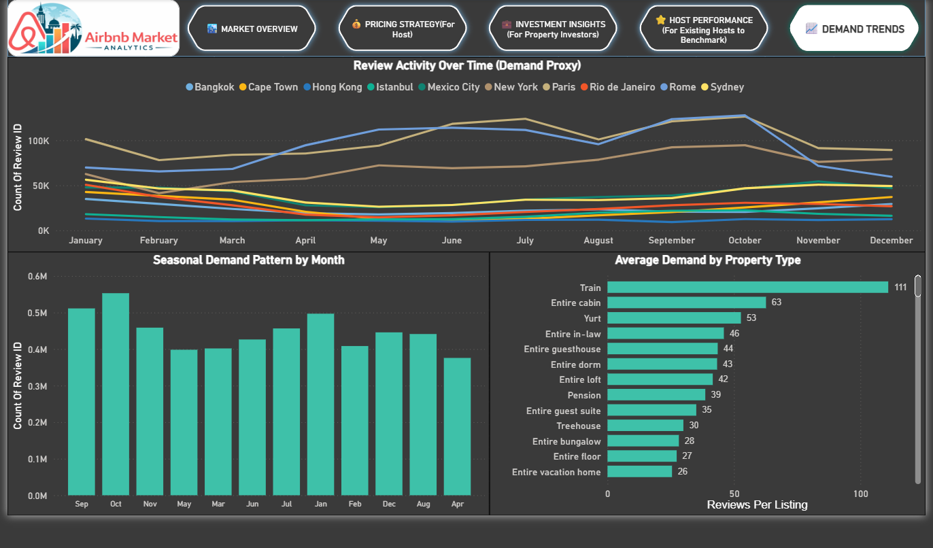

7.Business Recommendations
1. Pricing Strategy
- Adopt dynamic pricing based on seasonality (higher pricing in Sep-Oct peak months)
- Charge 20% premium for listings with 90+ ratings because high-rated properties support higher willingness to pay
- Benchmark prices against city averages:
  - Premium markets like Cape Town, Bangkok, Mexico City should maintain higher price bands
  - Value markets such as Paris, Rome, New York should focus on occupancy optimization
2. Property Configuration
- Prioritize entire apartments because they dominate demand (≈70% market share)
- Focus investments on 2-bedroom apartments which are the “pricing sweet spot”
- Target capacity of 3–4 guests to attract families and small groups
3. Quality & Rating Improvement
- Aim for review score ≥ 90 to unlock pricing premiums
- Improve:
  - cleanliness
  - accuracy of listing details
  - check-in convenience
- Encourage review collection to increase listing visibility
4. Superhost Strategy
- Work toward Superhost Status, as Superhosts earn ~20% higher pricing than regular hosts
- Maintain:
  - fast response rate
  - cancellation avoidance
  - high guest satisfaction
5. Location Optimization
- Prefer properties near:
  - transit hubs
  - major attractions
  - business districts
Because premium locations consistently command higher prices and demand
6. Market Entry Strategy
- Enter undersupplied high-price markets such as Hong Kong to maximize revenue per listing
- Use emerging markets (Cape Town, Bangkok) for luxury positioning
7. Operational Recommendations
- Minimum nights should balance occupancy & revenue (not too high)
- Enable Instant Book to increase booking conversion
- Offer:
  - Wi-Fi
  - AC/heating
  - kitchen facilities
  - workspace
because amenities significantly improve ratings and booking likelihood
8.Key Strategic Insights
1. Market Opportunity Analysis
High-Opportunity Markets:
- Cape Town and Bangkok represent premium opportunities with significantly higher average nightly rates ($2,405 and $2,078 respectively) compared to saturated European markets
- Hong Kong shows undersupply (only 2.5% of total listings) with premium pricing power ($746/night), indicating potential for new market entrants
- Emerging markets consistently command 2-3x higher prices than established European cities
Saturated Markets:
- Paris faces intense competition with 65K listings (23% of total market) driving prices down to $113/night
- Despite high supply, Paris shows low engagement (2.0 reviews per listing), suggesting guest dissatisfaction or market fatigue
- Rome and New York also show pricing pressure at $105 and $143/night respectively
Strategic Implication: New hosts should prioritize emerging markets (Cape Town, Bangkok, Mexico City) over saturated European cities for better revenue potential.

2. Optimal Property Configuration
Revenue-Maximizing Setup:
- Property Type: Entire apartments generate the highest revenue and account for 69.69% market share
- Bedroom Configuration: 2-bedroom properties command premium pricing at $687/night—the sweet spot between affordability and space
- Guest Capacity: Properties accommodating 3-4 guests show highest demand, aligning with family and small group travel patterns
Why This Matters: A 2-bedroom entire apartment accommodating 3-4 guests combines optimal space utilization with strong pricing power. This configuration appeals to the largest market segment (families and small groups) while commanding premium rates.

3. The Quality-Price Premium
Rating Impact:
- Listings with 90+ ratings can command approximately 20% higher prices than average-rated properties
- Quality ratings directly correlate with pricing power across all markets
- High ratings compensate for location disadvantages
Superhost Advantage:
- Superhosts achieve 20% pricing premium over regular hosts
- This status signals reliability, quality, and professional management
- Combined with high ratings, Superhosts can charge significantly above market averages
Actionable Strategy: Invest in property quality, guest experience, and responsive hosting to achieve Superhost status. The 20% premium quickly offsets improvement costs.

4. Seasonal Demand Patterns
Peak Booking Periods:
- Sep-Oct shows highest booking activity across all markets
- Hosts should implement dynamic pricing, raising rates 15-25% during peak months
- Off-season requires competitive pricing or value-added packages to maintain occupancy
Revenue Optimization: Implement seasonal pricing strategies with premium rates in Peak season and promotional rates or extended-stay discounts in Off-season.

5. Location Premium Strategy
High-Value Neighborhoods: Our analysis identified specific neighborhoods commanding 50-200% premiums over city averages:
- Proximity to tourist attractions, public transit, and business districts drives significant pricing power
- Within cities, location matters more than property size for premium pricing
- Waterfront, historic districts, and central business districts consistently outperform suburban locations

